AP Psychology Ch. 6 Memory pp. 226-268 Name ________________________________

1. Define Memory: ________________________________________________________

2. List the 3 Fundamental Processes of Memory:
Process | Refers to

3. List the 3 Stages (Stores) of Memory:
Make sure you understand the characteristics of each. Read pp. 228-9 and refer to the chart "Stage Model of Memory."
1. ___________________
2. ___________________
3. ___________________

4.
Briefly describe Sperling's study on Sensory Memory: What were his general findings?
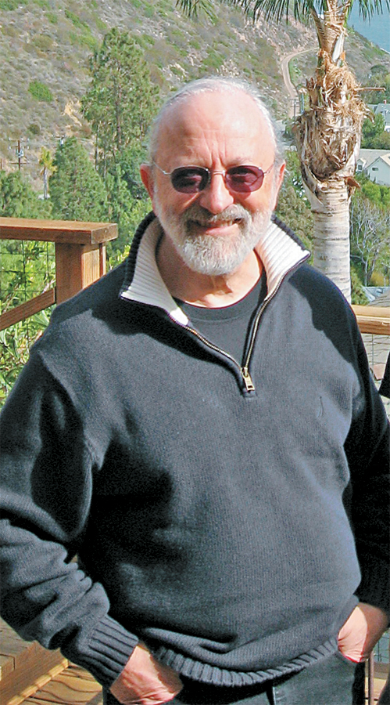

5. Fill in regarding the 2 Types of Sensory Memory:
Name | Type | Time Length

6. Fill in regarding the 2 Types of Rehearsal (Practice):
 | Maintenance (p. 231) | Elaborative (p. 234)
STM or LTM

Define

Give Example

7. Tell the difference between the 2 Ways Material is Lost from STM:
Interference | Decay

8. Explain the following:
STM capacity = 7+/-2 (or 4+/-1)

9. Define Chunking and explain how it helps STM: ___________________________________
____________________________________________________________________________

10. What is Working Memory?
Working Memory: The __________________ ___________________ and active, conscious
manipulation of _______________________________.

11. List the 3 components of Baddeley’s Model of Working Memory.
____________________________________________________________________________

____________________________________________________________________________

12. Fill in the chart regarding the Types of Long Term Memory:
Term | Define | Give Example
Procedural

 | Memories of particular events
That the US capital city is Washington D.C.
6 X 7 = 42

13. Fill in the chart regarding Dimensions of Long Term Memory:
 | Explicit (declarative) | Implicit (non-declarative)
Another name

Define

Types of LTM

14. Identify and define the following:
Name | Define
Tip-of-the-tongue experience (TOT)

Serial Position effect

15. Distinguish between Recall and Recognition:
 | Recall | Recognition
Define
Give Example

16. Fill in the chart regarding Encoding Specificity:
 | Context Effect | Mood Congruence
 | "External" | "Internal"
Define

Give Example

17. Outline the characteristics of Flashbulb Memory, give an example of it and comment on its accuracy:
Characteristics:

Example:

Accuracy:

18. Fill in the following chart regarding Interference:
Interference Types
Proactive Retroactive
Define:
Define:

Example:

Example:

19. Explain Ebbinghaus's Forgetting Curve:

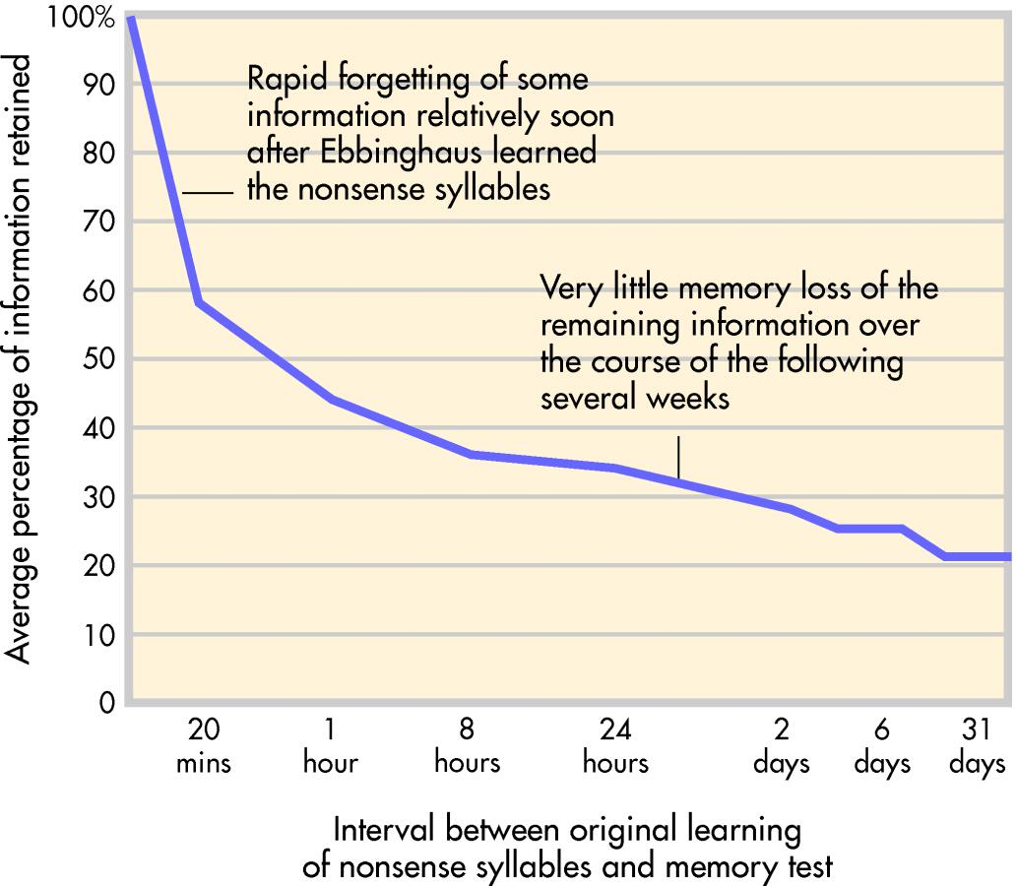
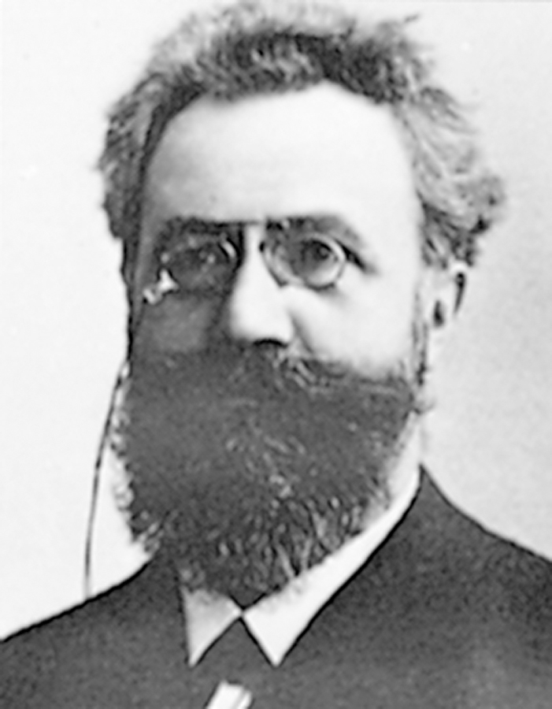

20. Fill In Why We Forget:
Encoding ______________________
________________________ Theory
________________________ Theory
Motivated _____________________
21. Fill In regarding Motivated Forgetting:
 | Suppression | Repression
Define

Give Example

22. Loftus says the Eyewitness Testimony can be _______________________.
23.
Misinformation Effect:

24A. Identify each researcher below by last name:
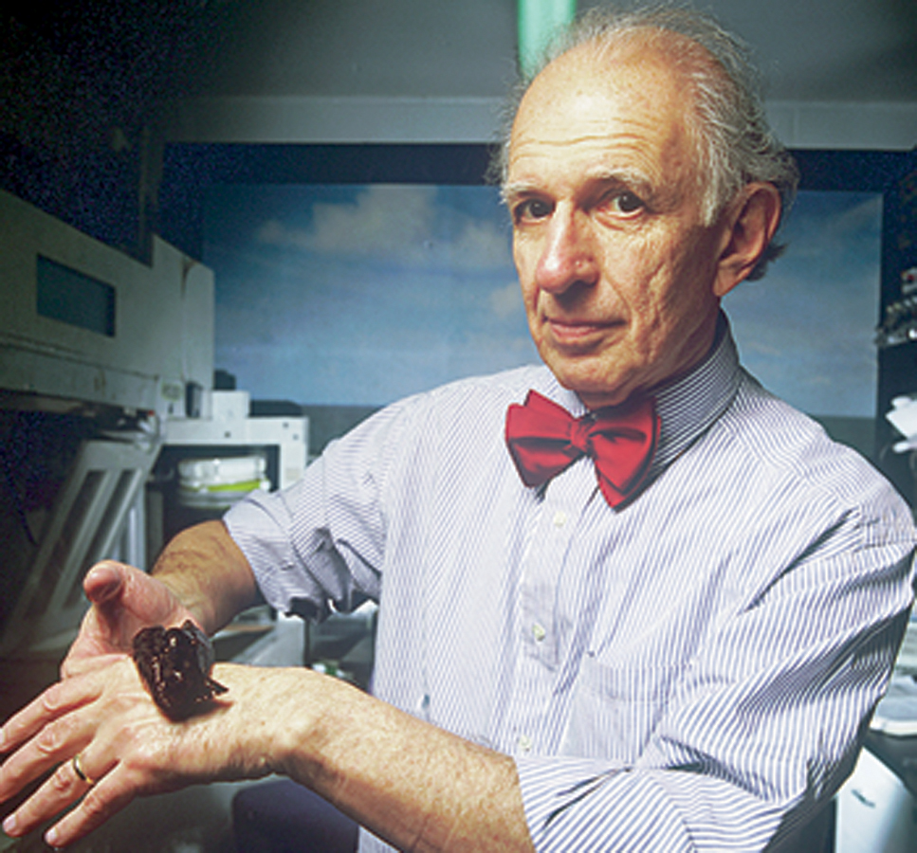
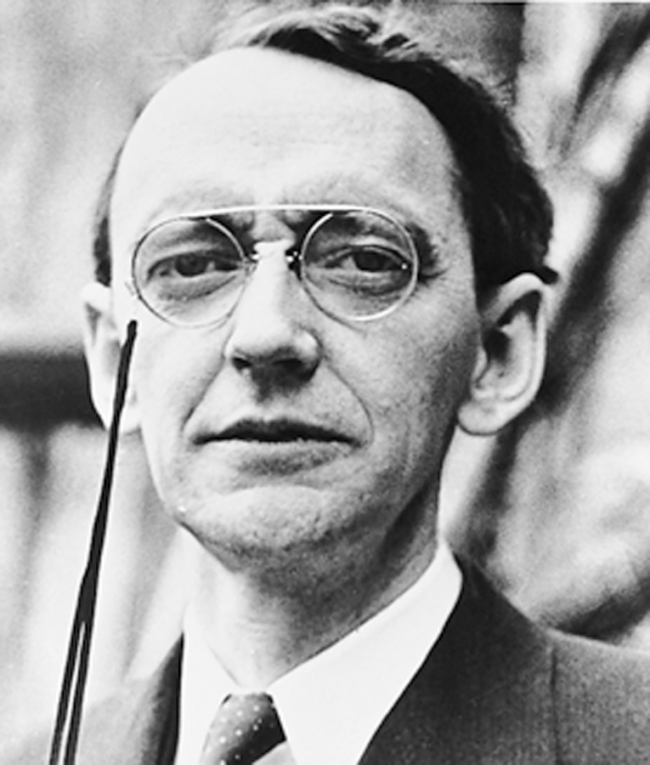

24B. Fill In the chart regarding the Biology of Memory Researchers:
 | Research | Description | Discovery
Lashley

Thompson

Kandel

25. Fill in the chart regarding Amnesia.
Retrograde |  | Anterograde
 | "means"
 | Define
 | Give Example

26. Label and define the 5 Memory Structures of the Brain:
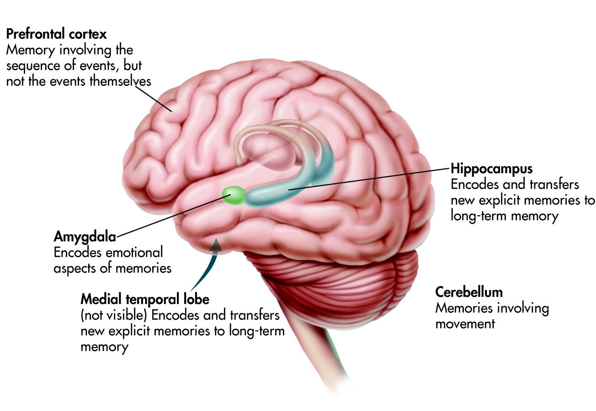

27. Distinguish between the following:
Dementia ___________________________________________________________________
Alzheimer's __________________________________________________________________

